(9th Green)

2022 Green Hill Golf Course
Information Guide.

Green Hill Municipal Golf Course
1929 Skyline Dr.
Worcester Ma 01605
508-799-1359
www.greenhillgc.com
Rates
 | Annual Memberships
 | Resident | Non-Resident
Unlimited Pass | $ 1,400.00 | $ 1,675.00
Weekday Pass | $ 1,000.00 | $ 1,200.00
Senior Weekday Pass | $ 900.00 | $ 1,125.00
Student Pass | $ 650.00 | $ 750.00
Junior Pass | $ 150.00 | $ 250.00
Millennial Membership | $ 850.00 | $ 950.00
Monthly Pass  Unlimited Veterans/Active Duty | $ 375.00  $ 1260.00 | $ 425.00  $ 1500.00
Weekday Veterans/Active Duty | $ 900.00 | $ 1125.00
 | Green Fees
NON RESIDENT GREEN FEES
18 Holes Monday - Thurs | $ 45.00
18 Holes Friday, Sat, Sun, Holidays | $ 50.00
18 Hole Friday, Sat, Sun, Holidays 12:00 | $ 45.00
18 Hole Friday, Sat, Sun, Holidays 3 PM | $ 35.00
9 Holes Fri., Sat., Sun., Holiday | $ 31.00
9 Holes Mon- to Thursday | $ 26.00
9 Hole Senior Mon to Thursday* | $ 21.00
WORCESTER RESIDENT GREEN FEES
18 Holes Monday - Thurs | $ 40.00
18 Holes Friday, Sat, Sun, Holidays | $ 45.00
18 Hole Friday, Sat, Sun, Holidays 12:00 | $ 40.00
18 Hole Friday, Sat, Sun, Holidays 3 PM | $ 35.00
18 Hole Senior Monday/ Thursday* | $ 32.00
9 Holes Fri., Sat., Sun., Holiday | $ 26.00
9 Holes Mon- to Thursday | $ 22.00
9 Hole Senior Mon to Thursday* | $ 20.00
18 Holes Junior Weekdays After 11:00 A.M. | $ 24.00
9 Holes Junior Weekdays After 11:00 A.M. | $ 17.00
Morning Special with Cart
18 Holes Monday-Thurs before 9AM  Veteran/Active Duty Mon-Thursday  Veteran/Active Duty Mon-Thursday | $ 42.00  $ 32.00 18 holes $ 20.00 9 Holes
Twilight | Walking | Riding
Monday-Thursday After 5 PM | $ 19.00 | $ 33.00
Friday-Sat-Sun and Holiday 5PM | $ 25.00 | $ 39.00
 | Carts Rental
 | 9 Holes | 18 Holes
Seniors(62) (Monday –Thursday) | $ 12.00 | $ 18.00
Regular | $ 14.00 | $ 21.00
Single Rider Surcharge | $ 10.00 | $ 10.00

USGA HANDICAPING SERVICE:
Starting in 2022 the Massachusetts Golf Association will begin migrating all handicaps to their proprietary members now program. : All golfers will purchase their GHIN handicaps through Members Now! The Members now portal begins January 4th.
Visit:

DRIVING RANGE:

1) The warm up bucket, 25 golf balls $5.00
2) The practice bucket, 75 golf balls $10.00
3) The Jumbo bucket, 120 balls $15.00
Pre-Paid Range: Minimum purchase $100.
Range Discount: 20% off all range purchases. With pre-paid purchase
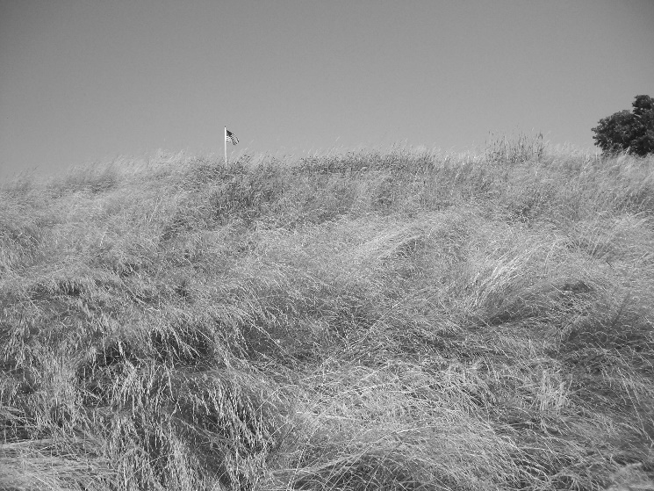

2022 Membership Classifications
Conditions for Resident Status: A player must be a year round resident of the City of Worcester and must present two proofs of the same upon application: (auto registration, driver’s license, utility bill or other proof of residency approved by the Commissioner). Property owners that do not reside in Worcester are not eligible for consideration as a resident.

Additional Passes
Additional passes for a family member may be purchased at a 20% discount per pass when adult pass is purchased. Discount applies to passes of equal or lessor value, to spouse and or children living at the same address under the age of 18.
Unlimited Pass: Pass provides for unlimited rounds of golf on weekdays, weekends and holidays. Not valid for the Walter Cosgrove Four Ball and Weekday Twilight Golf Leagues.
Millennial Membership: Pass provides for unlimited rounds of golf on weekdays, weekends and holidays. Ages 19 to 29. Not valid for the Walter Cosgrove Four Ball and Weekday Twilight Golf leagues.
Weekday Pass: Valid for unlimited play Monday-Friday non-Holiday periods. Not valid for the Walter Cosgrove Four Ball and Weekday Twilight Golf Leagues. Holidays where 5 day passes are not valid: Patriots Day, Memorial Day, Independence Day, Labor Day, Columbus Day, Passes not valid as a fee waiver for outside events scheduled at the course.
Senior 5 Weekday Pass: Individual who is 62 years of age at the time of application. Valid for unlimited play Monday-Friday non-Holiday periods. Not valid for the Walter Cosgrove Four Ball and Weekday Twilight Golf Leagues. Holidays where 5 day passes are not valid: Patriots Day, Memorial Day, Independence Day, Labor Day, Columbus Day, Passes not valid as a fee waiver for outside events scheduled at the course.
Junior: Any youth ages 10-18, prior to June 1st 2021 Junior Golf Permit valid Mon. Thru any time and Friday, weekend and holidays after 12 P.M. Not valid for the Walter Cosgrove Four Ball and Weekday Twilight Golf Leagues.
Student: Any youth, ages 19-22, prior to June 1st 2021 and are full time students living at the same address of a parent. Student Season Passes are restricted to weekdays any time and weekends and holidays after 12 P.M. Student must present current college ID card. Not valid for Holidays Not valid for the Walter Cosgrove Four Ball and Weekday Twilight Golf Leagues. 2022 will be the final year of the student pass.

Monthly Golfing Pass Detail:
- All monthly passes are automatically renewed on the first of each month unless canceled by the player.
- Automatic renewals are charged to the player’s credit card on the first of the month.
- A current and valid credit card must be placed on file at the time of application.
- Players are responsible to cancel their monthly pass prior to the first of the month.
- There are no partial refunds or adjustment made to the monthly pass amount regardless us use or days left in the month.
- Monthly pass allow unlimited play within normal golf course operations. Tee times required.
- Monthly passes do not qualify as a season permit eligible for reduced rates for twilight golf leagues.
- Monthly pass payments cannot be combined to be transferred into a full season permit.
- Monthly pass for month of November is $100.00
HOURS OF OPERATIONS

- The course shall be open for play through August, weather permitting, at 6:30 A.M. weekdays and 6:00 A.M. on weekends and holidays and will close at dusk each day.
- Fall hours: September-October opening at 8 AM daily, November 9 AM
- Course will be closed Thanksgiving Day.
- No play shall be allowed outside of hours of operation.
- Any changes to the hours of operation shall be posted at the course.

STARTING TIME POLICIES
- All players must have a starting time (tee time).
- Tee times are taken up to 7 days in advance. For example, a player may call for a Saturday tee time beginning the previous Saturday at 5pm.
- Only one tee time will be given per phone call.
- Tee times may also be booked on our website at www.greenhillgc.com

All tee times must be cancelled at least 24 hours prior. Failure to cancel a tee time may result in player being billed for the unused tee time space.
Special Tee Time Considerations: The pro shop reserves the right to place any players into special tee time consideration blocks.
- Ladies Day Tee Times (G.H.W.G.A.) shall be Wednesday 8AM.
- Monday Night Ladies League 5 PM front 9 shotgun start.
- Weekend Sweeps 10 AM to 11 AM
- Twilight Golf Leagues (Tue-Thursday 3:30)
- Additional Special tee times are at the discretion of the head golf professional.

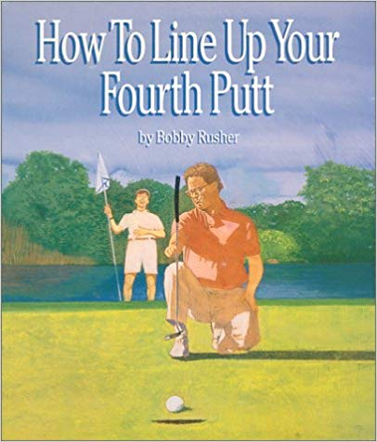

GENERAL RULES, SAFETY AND ETIQUETTE

Please keep in mind these general golf course rules and regulations during play
Note: Golfers assume full personal liability for all actions while using this facility.

The following is strictly prohibited. Violators may lose golfing privileges.
- Purposefully hitting balls into the pond or onto any hole other than the hole being played.
- Playing when the Course is closed (see hours of operation).
- Practicing on the Course.
- Walking onto the driving range.
- Playing more than one ball.
- Starting on the 10th tee without the permission of the Pro Shop.

General Rules
- Each player must have his or her own set of clubs.
- Use of golf carts is for players only. During events at the course there are no spectator carts allowed. This applies to golf matches, coaches and parents of players.
- Every player (pass holders included) must register in the Pro Shop prior to play.
- Green and cart fees cannot be split into separate rounds. A player paying for 18 holes may not choose to play 9 now and 9 later.
- Proper dress required.
- Privately owned power riding carts are not permissible.
- Proper conduct and language at all times. Verbal abuse of staff or other golfers shall result in suspension of player’s use of Green Hill Golf Course and facilities.
- Alcoholic beverages not purchased through the golf course will be strictly prohibited on premises. Any golfer caught bringing outside alcohol onto the course will be asked to leave without refund.
- Power carts must be kept behind white lines and signs. 90-degree rule for all paved paths. Players with handicaps/mobility issues may approach greens to accommodate their needs. At no time can carts be driven on tees/greens or approach collars. Cart path only is in effect all players must adhere to paths only.
- Holes must be played in succession.
- No rain checks will be given unless the course has been deemed unplayable. There will be no rain checks given for slow play.
- Purposefully hitting golf balls into Green Hill Pond is prohibited.
- Players clubs are prohibited from pro shop and snack bar areas.
- Maximum of 2 golf carts per tee-time allowed. Players wishing to ride solo and exceed the two cart maximum may do so with surcharge.
- Play ready golf, Replace all divots, Fix your ball mark as well as others.
- Lost balls, search 2 minutes. (Only for players with bad swings)
- Rake bunkers to a glass like fine smoothness.

Safety:
- Keep in mind the safety of rangers and maintenance staff.
- No playing from out of bounds (designated by white stakes).
- Leave golf course in the event of lightning or staff lightning warning.
- Be aware of your limits. Do not hit into the group in front of you.
- One group on a tee box at a time.
- Allow faster players to play through.
- Keep carts and pull carts away from tees and greens.
- When flags are out of cups, maintenance staff has right of way.

Driving Range:
- No use of range outside of normal golf course hours of operation.
- Last bucket of balls sold 30 minutes prior to sunset.
- Hawking of range balls is strictly prohibited.
- Lesson tee areas closed to public use.
- Walking onto range is strictly prohibited.
- Players must stay within marked hitting areas at all times.
- Range balls and buckets must remain at the course and cannot be removed.
- Players waiting for a hitting station must stay behind walkway at all times.
- Carts must remain in designated parking areas and are not allowed on the range.

EXPULSIONS, APPEALS and REFUNDS
SUSPENSION OR EXPULSION and APPEALS:

The Golf Professional, the Clubhouse Staff and the Course Staff shall enforce the rules of Green Hill Municipal Golf Course. Violation forms may be given to players for infractions. Immediate suspension may result for serious violations. The Commissioner, or his designee, may expel or suspend any player for any and all egregious confirmed violations of Golf Course rules and policies or in the event of a Golfing or Permit Holder's receipt of two or more violations during the course of a season. The person shall be notified by the Department as to the active date of suspension or expulsion. A player may appeal their suspension or expulsion notice to the Commissioner, or his designee prior to the activation date of said suspension by requesting a hearing. In the event no written contact is made prior to the activation date, suspension or expulsion shall begin on that date. Suspended players are not entitled to refunds or credits during their suspension. A hearing shall be set up upon request within a reasonable time frame. The player may bring with them any written information, witnesses, or other materials they feel may help their cause. All judgments at the hearing shall be final.

Membership credit:
A player may request a credit of their season golfing permit under the following guidelines. There are no cash refunds. Credits are given to the following year’s pass and are not transferable.
- Credit may be given all or in partial for medical reasons.
- Credit is not based on rounds played but rather how long the permit has been active.
  - Request made prior to the start of play, (course opening) may be entitled to a full refund.
  - Refund requests made in April may be entitled to a refund/credit up to 75% of the permits value.
  - Refund requests made in May, may be entitled to a refund/credit up to 50% of the permits value.
  - Refund requests made in June may be entitled to a refund/credit up to 25% of the permits value.
All requests must be made in writing. Any request after July 1st shall not be considered. All information must be submitted with written request. The Parks Commissioner or his designee shall be the sole determiner of any credit in part or whole. There shall be no cash refunds given once the golfing season has opened. Credits will be extended only until the next season and can only be applied towards the purchase of a new season permit. Credits are not transferable to any other person.

Bereavement/Transfer refund.
Refunds are available for military transfers and death of a player. Refund requests made prior to the start of the season are entitled to a full refund, requests made in April 75% refund, May 50% refund and June 25% refund. Requests made after June 30th shall not be considered.

Green Hill Golf Course Weather Policy
Green Hill G.C. does not possess an inclement weather warning system. Golfers are advised that they play at their own risk and the course is under no obligation to warn, retrieve and or remove anyone from the golf course due to inclement weather, including lightning. Golfers may suspend their round at any time upon their own determination of the dangers of existing, impending or threatening inclement weather and golfers may be eligible for a rain check. Green Hill Golf course is not responsible for injuries or damage resulting from inclement weather.

Driving Range rules and regulations
- No use of range outside of normal golf course hours of operation.
- Last bucket of balls sold 30 minutes before sunset.
- Lesson tee areas closed to public use.
- Walking onto range is strictly prohibited.
- Players must stay within marked hitting areas at all times.
- Range balls and buckets must remain at the course and cannot be removed.
- Players waiting for a hitting station must stay behind walkway at all times.
- Golf carts are assigned to players based on tee times. Players with carts at the range may have their cart used for players that are ready to tee off.
- No Smoking, shut cell phones off.
- For profit golf instructors must abide by course policy.

Golf Course Calendar 2022
April 26-27-27 Aerification
May 28-29 Match Play
June 11-12 Walter Cosgrove 4 Ball
June 25-26 Member-Member
Pending Danny Rossetti Kids Camp
July 30-31 Club Championship
Aug 10 Betty Ledger
Pending Fall Aerification
September 3-4 Labor Day 4 Ball

Season Permit Application 2022

Name: __________________________________________ Phone: ( ) _______ - __________

Address: ________________________________________ Birth Date: ______ /______ /_____

City: ____________________________________________ State: _____ Zip Code: ___________

e-mail address: __________________________________________________________________

Categories and Fees
Resident Non-Res
    - Unlimited Pass $1400.00 $1675.00
    - Weekday Pass $1000.00 $1200.00
    - Senior Weekday Pass $900.00 $1125.00
    - Student Pass $650.00 $750.00
    - Junior Pass $ 150.00 $250.00
    - Millennial Membership $850.00 $950.00
    - Unlimited Veteran/Active $1260.00 $1500.00
    - Weekday Veteran/Active $900.00 $1125.00

ALL RESIDENTS MUST BRING THE APPROPRIATE FORMS FOR PROOF OF RESIDENCY. All season permits must be paid in full at time of application. Golf Course staff cannot accept partial payments.

__________________________________________ _____________
Permit Category Price

________________________________ _____________
2022 Golfing Permit Applicant Signature Date

I, a Golfing Permit Holder applicant, have read, understand and acknowledge all rules, regulations and policies of the Green Hill Municipal Golf Course and agree to abide by. I have fully completed this application to the best of my ability and have provided all the information as requested in a forthright and truthful manner. In addition, I understand that my golfing permit and playing privileges will be suspended without refund for using false information to obtain a reduced rate golfing permit holder. Furthermore, I agree to hold the City of Worcester harmless from any claim for damages or injuries from my use of the Green Hill Municipal Golf Course.

Monthly Pass Application
2022

Name: __________________________________________ Phone: ( ) _______ - __________

Address: ________________________________________ Birth Date: ______ /______ /_____

City: ____________________________________________ State: _____ Zip Code: ___________

e-mail address: __________________________________________________________________

Worcester Residents at $375.00 per month and Non Residents for $425.00 per month

________________________________________________________ _____________
2022 Golfing Permit Applicant Signature Date

I, a Golfing monthly pass applicant, have read, understand and acknowledge all rules, regulations and policies of the Green Hill Municipal Golf Course and agree to abide by them. I have fully completed this application to the best of my ability and have provided all the information as requested in a forthright and truthful manner. In addition, I understand that my golfing pass and playing privileges will be suspended without refund for using false information to obtain a reduced rate golfing permit holder. Furthermore, I agree to hold the City of Worcester harmless from any claim for damages or injuries from my use of the Green Hill Municipal Golf Course.
Monthly Golfing Pass Detail:
- All monthly passes are automatically renewed on the first of each month unless canceled by the player.
- Automatic renewals are charged to the player’s credit card on the first of the month.
- A current and valid credit card must be placed on file at the time of application.
- Players are responsible to cancel their monthly pass prior to the first of the month.
- There are no partial refunds or adjustment made to the monthly pass amount regardless us use or days left in the month.
- Monthly pass allow unlimited play within normal golf course operations. Tee times required.
- Monthly passes do not qualify as a season permit eligible for reduced rates for twilight golf leagues.
- Monthly pass payments cannot be combined to be transferred into a full season permit.
- Monthly pass for month of November is $100.00

